**MINUTES OF THE THEBERTON AND EASTBRIDGE PARISH COUNCIL MEETING HELD   
AT THE JUBILEE HALL, THEBERTON ON WEDNESDAY 13th FEBRUARY AT 6:45 PM**

1. **Attendance and Apologies**

|  |  |
| --- | --- |
| **Attendees:** Cllr. Stephen Brett - Chair  Cllr. Hilary Ward - Vice-Chair Cllr. Philip Baskett  Cllr. Paul Collins  Cllr. Beth Goose Cllr. Julian Wallis | **Apologies for absence:** Cllr. Stephen Morphey - written and accepted  Cllr. Graham Bickers - written and accepted Cllr. Joan Harvey - written and accepted District Cllr. Tony Cooper County Cllr. Richard Smith  **In attendance:**  Sharon Smith - Clerk/RFO District Cllr. Susan Geater |

1. **Declarations of Pecuniary and Non-Pecuniary Interests**

None.

1. **Public Forum**

None.

**4.** **Minutes of the Meetings**

The minutes of the meetings held on 9th January 2019 and 17th January 2019, copies of which had been previously circulated, were proposed by Cllr. Beth Goose and seconded by Cllr. Paul Collins. They were approved as true and accurate records and were signed by the Chair.

**5. Matters Arising**

None. Outstanding actions are detailed in **Appendix I.**

**6. Meetings and Progress Reports**

a) Eastbridge Playing Field - the play equipment has been installed and thanks were given to Cllr. Paul Collins for delivering a successful project. In response to a complaint received from a resident regarding the decision to upgrade the play equipment, the Council noted that the decision was made by Full Council and was not proposed nor decided on by any individual Councillor. The Council were in a position to consider updating the current equipment and were able to obtain grants from organisations willing to contribute, with a modest contribution from the Council, to achieve this. The primary reason for installing new play equipment was prompted by reports received by the Council on the condition of the existing play equipment in the field.  The Suffolk Coastal District Council Outdoor Playing Scheme Parish Schedule reported deficiencies in the standard and quality of the equipment and proposed improvements be made to upgrade the facilities to LEAP standards.  The Council’s annual play equipment safety inspection report from ROSPA stated that the equipment was not compliant with the requirements of the relevant standard. The Council considers the play equipment to be an asset to the community that will be used now and in the future by children, grandchildren and visitors. It was agreed to remove the old swing sets shortly to ensure all the play equipment is safe to use.

b) Defibrillators - it was agreed to ask for volunteers to attend a training session via the village newsletter, the Yoxmere Fisherman and the Eel’s Foot Inn Facebook page.  
ACTION: Cllr. Hilary Ward, Cllr. Beth Goose and Cllr. Julian Wallis to progress.

c) Grit Bin - a possible location has been identified. ACTION: Cllr. Stephen Brett to discuss with the landowner.

d) Police - no crimes were reported in December 2018.

e) Speed Indicator Device - report attached as **Appendix II**.

**7. Consultations**

a) The Council postponed receipt of the monthly TEAGS report.

b) The Council decided not to respond to the final draft Suffolk Coastal Local Plan.

c) The Council postponed the decision whether to respond to Scottish Power Renewables stage 4 public consultation.  
ACTION: Clerk to add to next month’s agenda. Cllr. Stephen Brett to attend SPR’s public exhibition.

**8. Villages**

a) The Council agreed to request that planning application DC/18/5232/FUL is referred to the planning committee.  
ACTION: Clerk to inform the planning department.

b) The Council agreed to support the Community Council’s proposal to register The Lion Inn as an Asset of Community Value.

c) The Council agreed to register The Eel’s Foot Inn as an Asset of Community Value.  
ACTION: Clerk to progress.

**9. Administration**

a) The Council agreed to sign a SALC Payroll Service Level Agreement.

b) The Council discussed the key points regarding the Parish Council election scheduled in May 2019 and noted interest from new candidates.

**10. Finance**

a) The Council noted the latest financial position detailed in **Appendix III**.

b) The Council approved the bank reconciliation for quarter 3 2018.

c) The Council postponed establishing a sinking fund to cover the cost of repairs and replacement of play equipment.  
ACTION: Clerk to add to next month’s agenda.

d) The Council decided not to apply for a grant from an AONB Fund at this time.

e) The Council authorised the payment listed below. Proposed by Cllr. Beth Goose. Seconded by Cllr. Paul Collins. All in favour.

|  |  |  |  |
| --- | --- | --- | --- |
| **Details** | **Payee** | **Amount** | **Power** |
| Village Hall Rent for Planning Aid England Workshop | Middleton Village Hall | £15.00 | LGA 1972 s.111 |
| Internal Audit - replacement for lost cheque 100636 | Heelis & Lodge | £108.00 | LGA 1972 s.111 |
| Eastbridge Play Equipment - 30% further payment (payable immediately) | Sovereign Design Play Systems Limited | £5,747.87 | LGA 1972 s.111 |
| Clerk’s Training - Elections Briefing (shared with Yoxford and Middleton Parish Councils) | Suffolk Association of Local Councils | £10.00 | LGA 1972 s.111 |

**11. Correspondence**

The Council noted the correspondence received between 6th January 2019 and 7th February 2019 detailed in **Appendix IV**.   
  
**12. Questions to the Chair**

None.

**13. Date and Time of Next Meeting**

The date and time of the next meeting of the Council is scheduled for Wednesday 13th March 2019 at 7:30 pm.

The meeting closed at 7:25 pm.

A presentation about Sizewell C followed from Tom McGarry, Head of Communications for Sizewell C, Richard Bull, Head of Transport Planning for New Nuclear, Katy McGuinness from the Planning team and Matt Elliot, Site Manager for Sizewell C. They also answered questions and listened to concerns from the Council and the public.

**Appendix I - Outstanding Actions**

|  |  |  |  |  |
| --- | --- | --- | --- | --- |
| **Meeting Date** | **Item Ref** | **Action** | **Responsibility** | **Comments** |
| 11/01/17 | 5a | Ascertain quantity of documentation to be stored and obtain quote from Sizewell Storage. | Clerk and Cllr. Joan Harvey | 06/02/18 - to form part of the GDPR review. |
| 06/09/17 08/11/17 | 5b 7c | Send SID data to SCC Highways and request a visit from the speed camera unit. | Cllr. Stephen Brett/Clerk |  |
| 06/09/17 | 5g | Order two playpark ownership signs. | Clerk. | 13/06/18 - updated under item 10b |
| 06/09/17 | 6e | Ascertain whether a litter bin can be placed on Highways land, whether Suffolk Norse will empty it and whether the sign can be renewed at the Theberton layby. | Clerk | 13/06/18 - updated under item 5c. |
| 08/11/17 | 10a | Purchase work party tools to the value of £515. | Cllr. Stephen Brett |  |
| 08/11/17 | 12a | Draft an emergency plan and add to a future agenda for approval and also consideration of the provision of grit bins. | Clerk | 29/11/18 - grit bin requested from County Cllr. Richard Smith |
| 10/01/18 | 5a | Install gate at Theberton play area. | Cllr. Stephen Brett and Cllr. Graham Bickers | 29/11/18 - posts installed |
| 15/08/18 | 5c | Apply to Outdoor Play Scheme Fund for a grant to replace slide and provide a climbing frame at Theberton play area. |  |  |
| 12/09/18 | 7a | Ask the Jubilee Hall Management Committee if they would like a grit bin sited inside the fenced gateway to the car park. | Cllr. Graham Bickers |  |
| 10/10/18 | 8 | Circulate dates of future SALC Suffolk Coastal Area Meetings. | Clerk |  |
| 10/10/18 | 10b | Write a Chairman’s letter to a resident asking him to moderate his way of communicating with the Council. | Cllr. Stephen Brett/Clerk |  |
| 09/01/19 | 8c | Establish a sinking fund to cover the cost of repairs and replacement of play equipment. | Council | Waiting for information from Sovereign |

**Appendix I - Speed Indicator Device Data**

The speed indicator device has been operational for twenty-six ~20 day periods since 20th December 2016. It is placed at one end of the village or other at ~30 day intervals.

Last month the SID was placed at the south end of the village but turned around to watch the traffic leaving the village. There is a drop in number of vehicle movements but that may be due to the SID being confused when traffic is going in both directions. So whilst the vehicle movements data may be low, the more interesting statistics are that the percentage exceeding 35mph has decreased to 16.7% and the 85 percentile speed* is 35.7mph compared to 40.7 when they enter from the north showing that vehicles are slowing down compared to when they enter the village from the Middleton end.

It will be interesting to see if the same situation prevails when the SID is placed at the north end of the village looking at the traffic leaving the village.

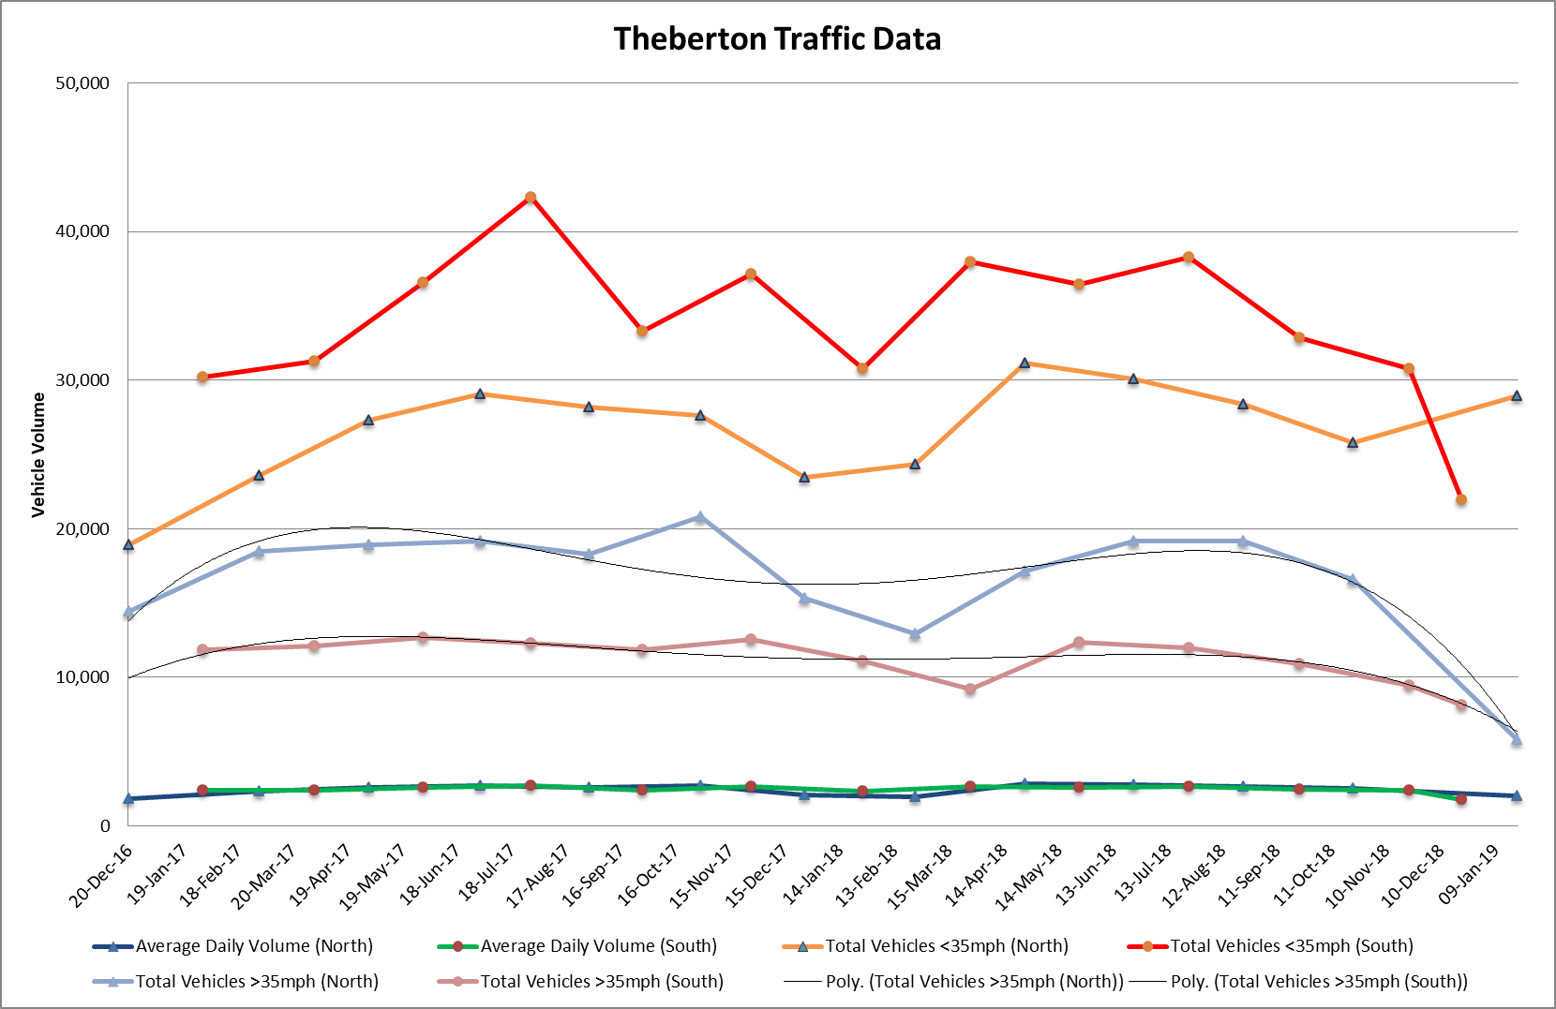



**\*The 85th Percentile is indicative of the speed that the majority of road users are travelling at.**

**Appendix III - Financial Position**

|  |  |
| --- | --- |
| **Bank Balances as at 10th January 2019** |  |
| Barclays Current Account | £11,324.28 |
| Barclays Savings Account | £1,513.77 |
|  | **£12,838.05** |
|  |  |
| **General and Earmarked Reserves** |  |
| EDF Energy Grant - Work Party Tools | £515.00 |
| Earmarked - Eastbridge Common Legal Costs | £600.00 |
| General Reserves | £2,495.00 |
|  | **£3,610.00** |
|  |  |
| **Bank Balance less Reserves** | **£9,228.05** |
|  |  |
| **Income - February/March 2019** |  |
| SCDC - Outdoor Playing Space Scheme | £4,675.00 |
| HMRC - VAT Reclaim | £4,552.55 |
|  | **£9,227.55** |
|  |  |
| **Payments - February 2019** |  |
| Business Services at CAS - Defibrillators Insurance | £15.03 |
| CCC Finance - Eastbridge Play Equipment | £15,327.60 |
| Middleton Village Hall - Rent | £15.00 |
| SALC - Clerk’s Election Training | £10.00 |
| Heelis & Lodge - Replacement Cheque | £108.00 |
| Westcotec - Replacement Allen Keys | £9.00 |
|  | **£15,484.63** |
|  |  |
| **Net Balance** | **£2,970.97** |

**Appendix IV - Correspondence**  
Suffolk Association of Local Councils

a) E-Bulletin – 04/01/19, 18/01/19, 31/01/19  
b) School Travel Policy Changes  
c) MHCLG Communities Framework  
d) Free Digital Mapping Workshop

District Council and County Council

a) SCDC - Suffolk Coastal Local Plan - Briefing Session and Presentation Slides  
b) SCDC - Suffolk Coastal Local Plan - Final Draft  
c) SCDC - Cllr. Tony Cooper’s Monthly Report - February 2019  
d) SCDC - Love East Suffolk 2019 Litter Pick  
e) SCDC - Become one of the first East Suffolk Councillors Poster and Information Days  
f) SCC Highways - Road Repairs - Harrow Lane and Potters Street

Suffolk Constabulary

a) Safer Neighbourhood Team Newsletter - January 2019  
b) Locality Meeting - 18/03/19

Energy Companies  
  
a) Planning Aid England - Sizewell C Stage 3 Consultation - Support to Parish and Town Councils  
b) Planning Aid England - Briefing Sessions and Presentation Slides  
c) Planning Aid England - Further General Workshops  
d) EDF Energy - Sizewell C Stage 3 Public Consultation Begins  
e) EDF Energy - Sizewell B Community Newsletter - December 2018  
f) EDF Energy - Sizewell C Project Update - February 2019  
g) Substation Action/Save East Suffolk - National Grid Interconnector Projects  
h) Substation Action/Save East Suffolk - East Suffolk Energy Projects  
i) Substation Action/Save East Suffolk - East Suffolk Under Threat  
j) Darsham Parish Council - Poster re Sizewell C Public Meeting  
k) Sizewell Parishes Liaison Group Meeting and Chairman’s Statement  
l) Scottish Power Renewables - Phase 4 Public Consultation  
m) CTC Suffolk Cycling Group - Sizewell C Infrastructure Changes  
n) AONB Meeting Presentation Slides  
o) Emails from residents - Sizewell B Relocated Facilities - Public Consultation Response

Other

a) AONB Grants Open for Applications  
b) AONB Monthly Update - January 2019  
c) Email re HM Doughty and HMS Hermione 1914  
d) Emails from a former resident of Pretty Road  
e) Email re Zeppelin L48  
f) British Red Cross - Appeal for Volunteers  
g) Suffolk Preservation Society - Heritage Training  
h) Email from a resident re Eastbridge Playing Field